Name: Akash Arjun Sawant
Student ID: AF05009971
Batch code: ANP-D1396

Day 5 Lab

Assignment 1. A restaurant owner wants to create a Webpage to display menus along with prices and videos of popular dishes.
Create an HTML page using text formatting tags and select some videos from the
internet. Use internal styles.

Code:

<!DOCTYPE html>
<html lang="en">
<head>
<meta charset="UTF-8" />
<meta name="viewport" content="width=device-width, initial-scale=1.0" />
<title>Sky's Restaurant</title>
<style>
body {
margin: 0;
font-family: Arial, Helvetica, sans-serif;
background-color: #f4f4f4;
}
.navbar {
background-color: #2b2f32;
padding: 15px 30px;
color: white;
font-size: 20px;
display: flex;
justify-content: space-between;
}
h2 {
margin-left: 60px;
margin-top: 40px;
font-size: 35px;
}
.menu-container {
display: flex;
justify-content: space-between;
flex-wrap: wrap;
width: 85%;
margin: auto;
}
.card {
background-color: white;
width: 40%;
margin-top: 20px;
padding: 20px;
border: 1px solid #ddd;
border-radius: 8px;
}
.card img {
width: 85%;
height: 370px;
border-radius: 5px;
}
.dish-name {
font-size: 28px;
font-weight: bold;
margin-top: 15px;
}
.desc {
font-size: 17px;
margin: 10px 0;
}
.price {
font-size: 18px;
font-weight: bold;
}
.video-section {
display: flex;
justify-content: center;
}
.video-section iframe {
width: 800px;
height: 430px;
}
footer {
background-color: #0e0908;
color: white;
text-align: center;
padding: 25px 0;
margin-top: 50px;
font-size: 0.95em;
}
</style>
</head>
<body>
<div class="navbar">
<div>Sky's Restaurant</div>
<div>
<a href="#menu" style="color: white; margin-right: 20px">Menu</a>
<a href="#popular" style="color: white">Popular Dishes</a>
</div>
</div>

<h2 id="menu">Menu</h2>

<div class="menu-container">
<div class="card">
<img src="images/pizza.jpg" alt="Pizza" />
<div class="dish-name">Pizza Supreme</div>
<div class="desc">
Pizza sauce, mozzarella, bacon, onion, capsicum, pepperoni, mushrooms,
olives
</div>
<div class="price">Price: ₹250</div>
</div>

<div class="card">
<img src="images/paneer-tikka.jpg" alt="Paneer Tikka" />
<div class="dish-name">Paneer Tikka</div>
<div class="desc">
Paneer, yogurt, spices, bell peppers, onions, baby corn, mushrooms
</div>
<div class="price">Price: ₹200</div>
</div>
</div>

<h2 id="popular">Popular Dishes</h2>

<div class="video-section">
<iframe
src="https://www.youtube.com/embed/xdshDFwu9x4?autoplay=1"
title="YouTube video player"
frameborder="0"
allow="accelerometer; autoplay; clipboard-write; encrypted-media; gyroscope; picture-in-picture; web-share"
referrerpolicy="strict-origin-when-cross-origin"
allowfullscreen
></iframe>
</div>
<footer>
<p>&copy; 2025 Sky's Restaurant. All rights reserved.</p>
</footer>
</body>
</html>

Output:

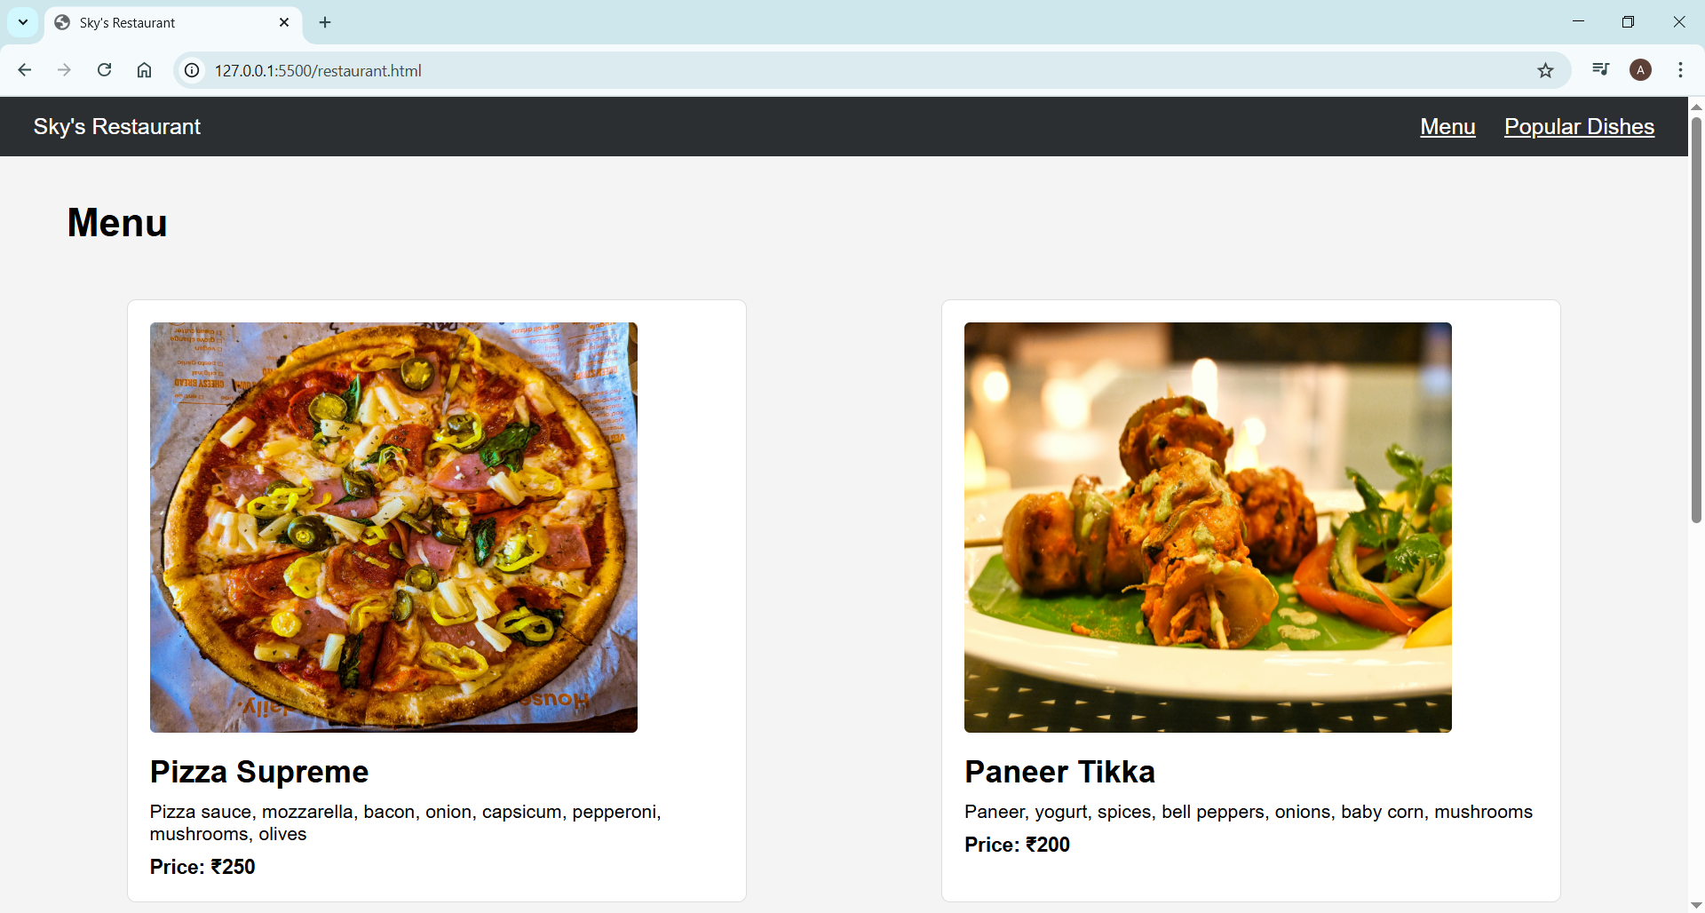
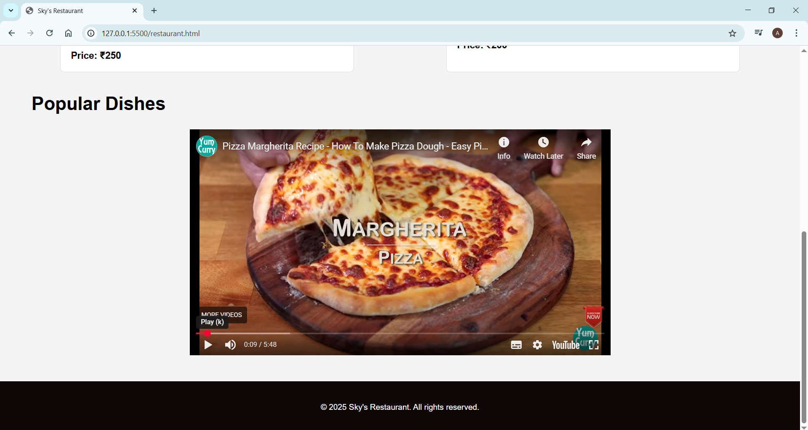

Q. Ask ChatGPT
Suppose you want to create the user interface for two different types of websites. One is a Hospital website and another is a Movie Ticket booking website. You want to know what is the correct choice of colors for these websites. Design a prompt and ask ChatGPT to help you with good and bad UI.

Designed Prompt:
"I am designing user interfaces for two different websites: a Hospital website and a Movie Ticket Booking website. Please suggest:
- The best color combinations for each website.
- Colors that should be avoided for each.
- A comparison of good vs bad UI for these websites.
- Examples of how the color choices affect user experience and trust.
- A small sample UI layout for both websites using your recommended colors."

ChatGPT Response:
1. Best Color Combinations for Each Website

Hospital Website – Good UI Colors
Purpose | Recommended Colors
Primary Background | Soft white, light grey (#F5F5F5)
Accent Colors | Blue (#1E88E5), Teal (#00897B)
Buttons / CTA | Green (#4CAF50) or Blue (#1976D2)
Text | Dark grey (#333333) or black
Why these colors?
✔ Blue and green create trust, calmness, safety.
✔ Clean white layout gives a professional, hygienic feel.
✔ Blue is widely used in healthcare because it looks clean and reliable.

Movie Ticket Booking Website – Good UI Colors
Purpose | Recommended Colors
Primary Background | Dark theme (#121212), charcoal black (#1C1C1C)
Accent Colors | Red (#E50914), Yellow (#FBC02D), Purple (#7E57C2)
Highlights / Ratings | Gold (#FFD700)
Text | White (#FFFFFF) or light grey
Why these colors?
✔ Dark themes match cinematic environments.
✔ Red and yellow create excitement and energy.
✔ Bright accents highlight buttons and movie posters.

2. Colors to Avoid

Hospital Website – Bad Choices
Avoid | Reason
Bright red | Associated with danger, panic, blood
Dark black backgrounds | Looks harsh, not medical
Neon colors | Unprofessional and distracting
Too much yellow | Can feel alarming or unhygienic

Movie Ticket Booking Website – Bad Choices
Avoid | Reason
Pastel colors | Not energetic, doesn't match cinema theme
Too much white | Feels like a hospital/office
Faded greys | Makes posters dull
Dark red background with red buttons | Poor contrast, bad readability

3. Good UI vs Bad UI (Comparison)
Website Type | Good UI | Bad UI
Hospital | Clean white background, calming blues & greens, clear readability, soft borders | Heavy reds, clutter, low contrast, too many colors
Movie Booking | Dark theme, bright accents, large images, clear CTA buttons | Light pastel theme, dull contrasts, crowded posters, small fonts

4. How Color Choices Affect UX
Hospital Website
- Good colors improve trust and professional feel.
- Calm colors reduce stress for patients.
- Bad colors create fear or confusion.
Movie Booking Website
- Bright accents increase excitement and urgency to book.
- Dark backgrounds enhance movie poster visibility.
- Bad colors make the site feel boring and reduce engagement.

Hospital Website UI Sample
Header: White background, blue text (#1E88E5)
Buttons: Green (#4CAF50)
Sections: Light grey backgrounds (#F5F5F5)
Links: Teal (#00897B)
Footer: Soft blue background (#E3F2FD)

Movie Ticket Booking UI Sample
Background: Dark black (#121212)
Header: Dark grey (#1F1F1F)
Buttons: Red (#E50914) with white text
Highlights: Golden yellow (#FFD700)
Movie Cards: Enclosed in charcoal grey (#2A2A2A)
Text: White (#FFFFFF)

If you want, I can also create actual HTML templates for both websites using these colors.

